**Decomposition Trees allow the user to visualise how data (measures or aggregates) is distributed across multiple dimensions.**

**Decomposition Trees can be configured manually for data exploration, or leverage AI to support root cause analysis.**

**Supposing that the executive come back to me and say ‘Our Return Rate is higher than we are comfortable with. What might be the root cause or diagnose what’s driving that return rate?**

**In the 1st example I analysed the measure Return Rate at a very high level of Product Brand, and also at the Product Name level.**

**In the 2nd example I analysed Total Number of Transactions at Product Brand and Product Name levels.**

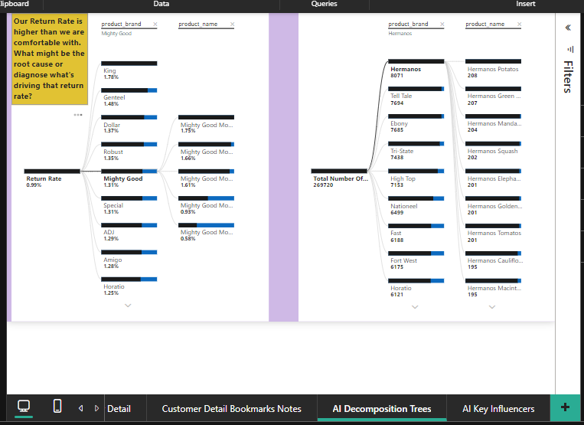

**The key influencer visual helps the user understand the factors that drive specific metric or outcomes.**

**What drives whether or not a customer owns a home?**

**Analyse: HomeOwner**

**Explained by: Yearly Income, Education, Marital Status and Occupation**

